# 23/24(1) ELEC5570M Control Systems Design (27439)

# Coursework Assignment

**Major: Electronic and Electrical Engineering**

# Name: Zou Longfei

# Student ID: 201777135

**Part A: Root Locus**

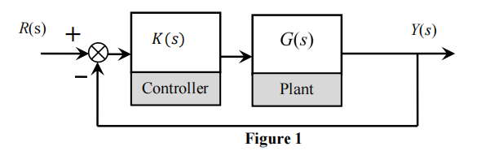

Here is the plant in Figure 1 and we have to design a PID controllers. Besides, we have the close-loop system transfer function G(s).

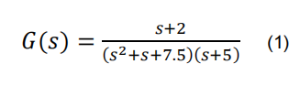

**Task1 1.1) We can see the picture of the root locus under a scalar gain by typing the following code.**

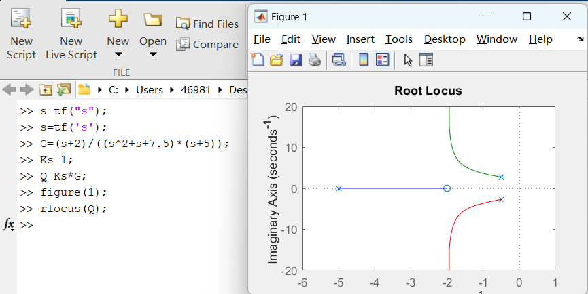

**Task1 1.2) As we know that we can use the approximation way for second-order to calculate the 2% setteling time.**

**Ts = 4 / ζ * Wn**

**However, there are 3 poles in this root locus in the task 1.1. So, we have to use the method to appoximate the third-order system and create the collision point. Then we can create a new second-oreder system and find the point to estimate the settling time Ts.**

**So, I come up with a first way which is very simple to estimate the Ts (even though it might be unaccurate). We use the locus plot we have plotted in the task1.1 and ignore the the farther pole where s = -5 . We only focus on two conjugate complex pols which have the limit of s= -2 . At that time the lowest Ts is 4 / 2 = 2 s**

**However, another way is that we also can use the formula to approximate the third-order system and calculate the Ts. Then use Matlab to calculate the step response of the original third-order system to find the real 2% settling time. Finally use it to compare with our estimated Ts.**

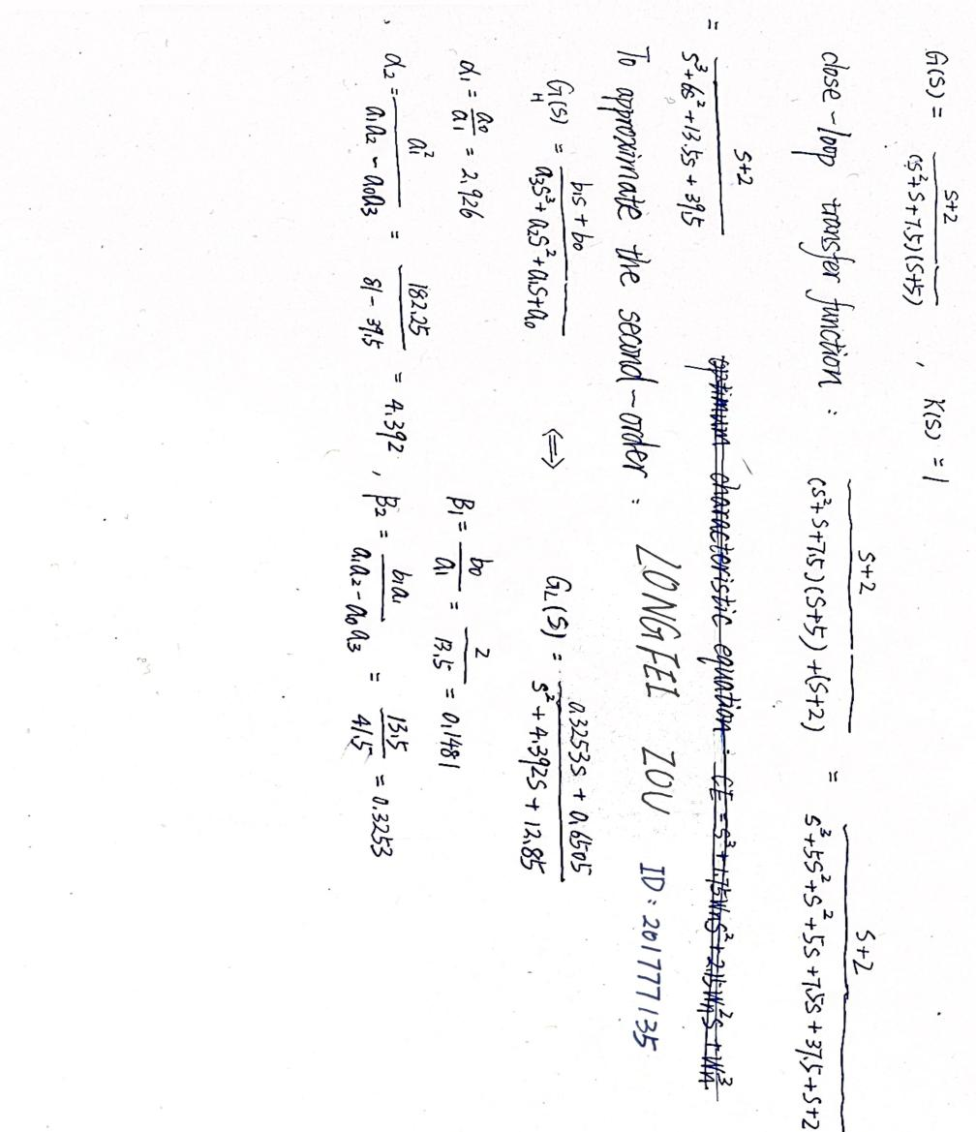

**Now we have the GL(S) = (0.3253s + 0.6505) / (s^2+4.392s+12.85) and have the step response when k = 1. The Ts approximated as 1.91 (as 0.0482*0.98=0.4724)**

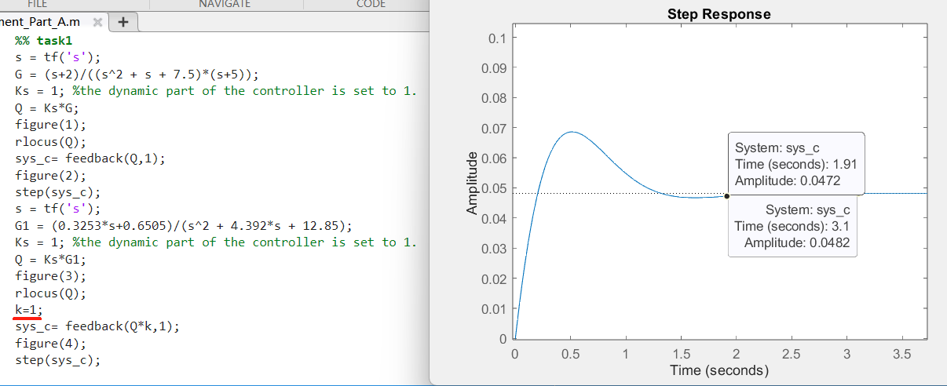

**Task2 2.1): We can use PD controller to improve the settling time and change the root locus. We let S = -5 and need to confirm the value of Z1. To calculate this, we have to use the phase condition to confirm Z1. The process of calculation is given here:**

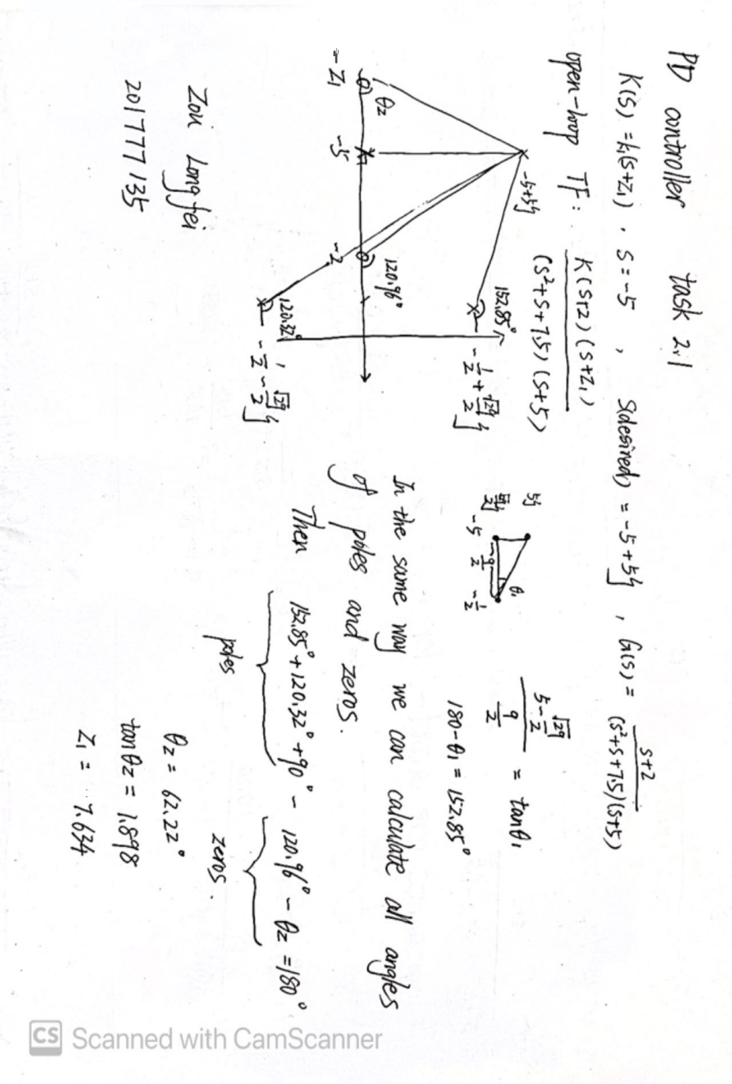

**Task2 2.2): To calculate value of k, we have to use the condition of amplitude.We can obtain that the value of k is 6.841**

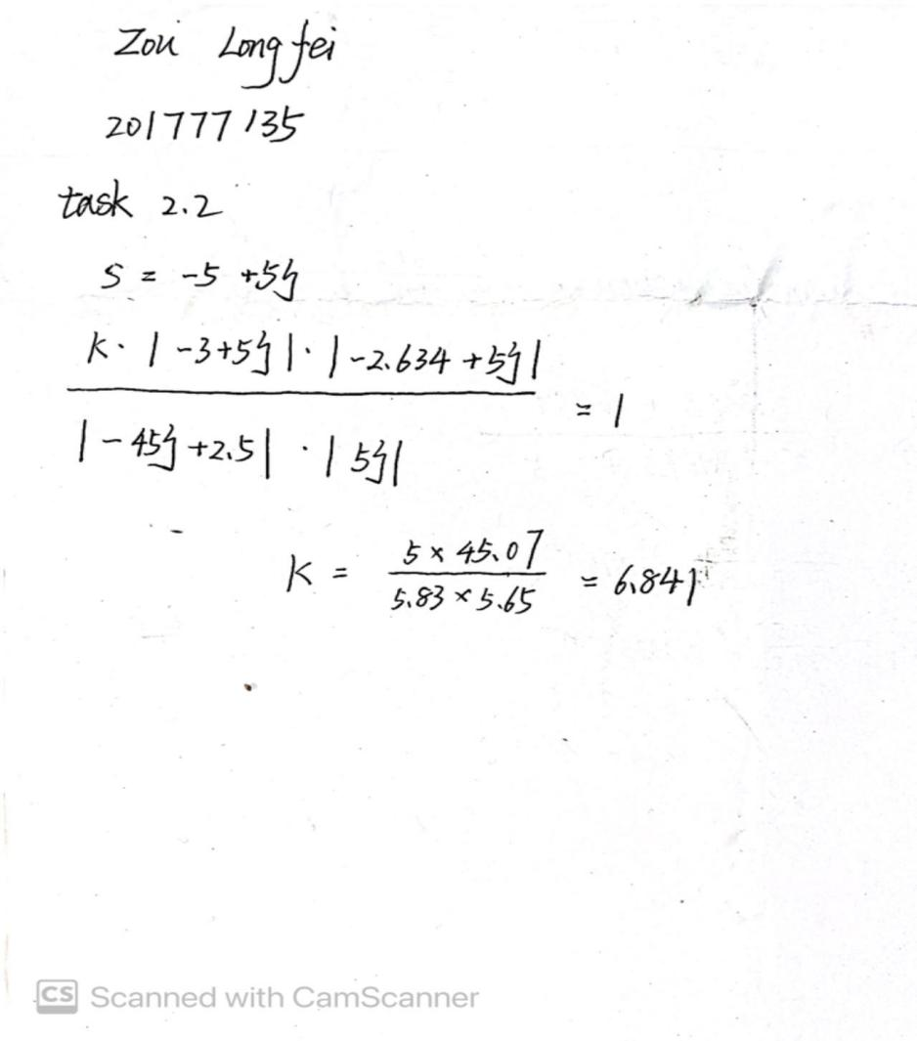

**Task2 2.3):**

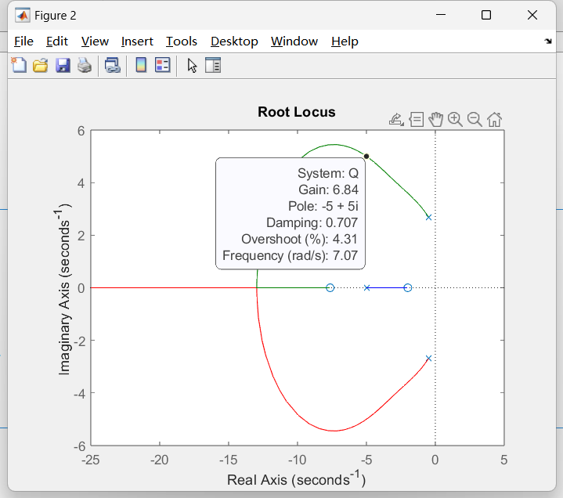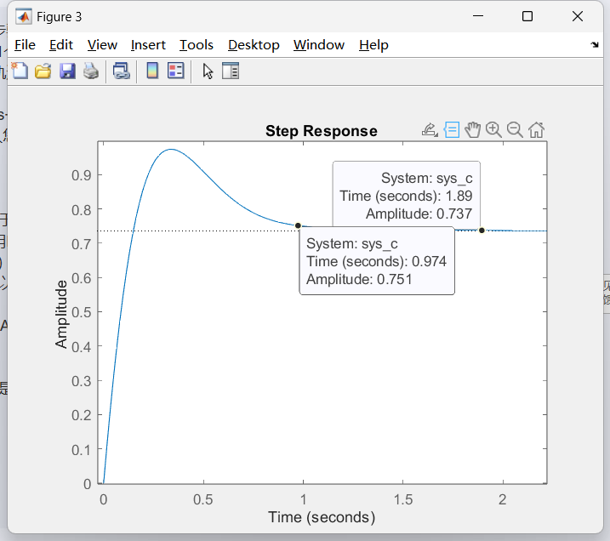

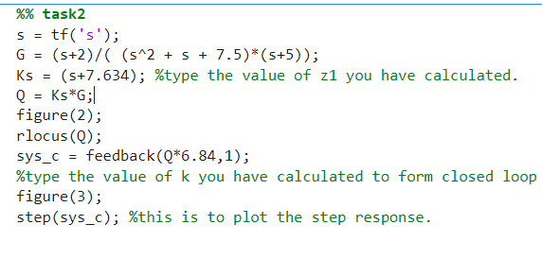

**Task3 3.1): we use the phase condition to find Z1 and use the amplitude conditon to calculate k values.**

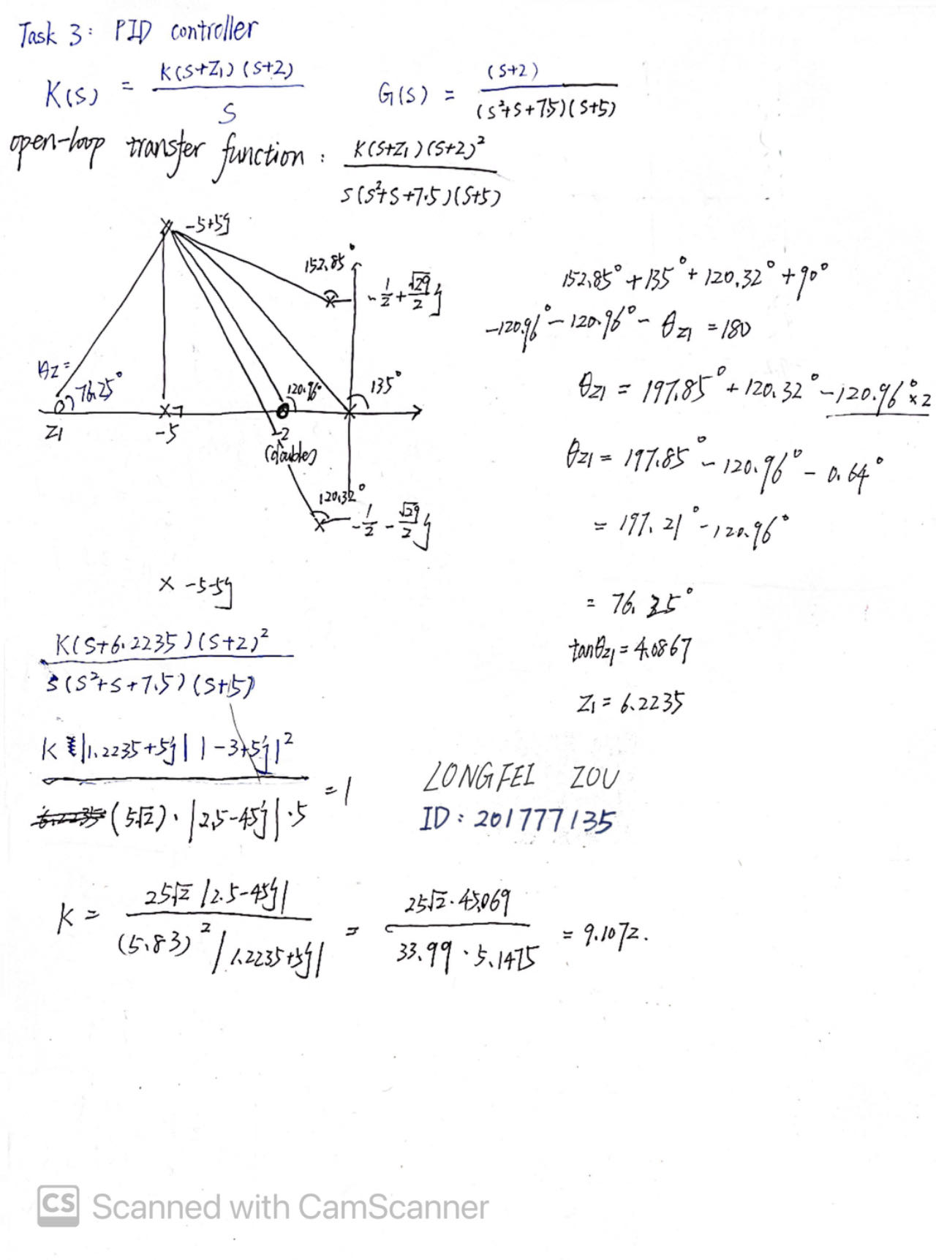

**Task3 3.2): we have got a new transfer function now, so we type the value of z1 and k to get new images of root locus and step response.**

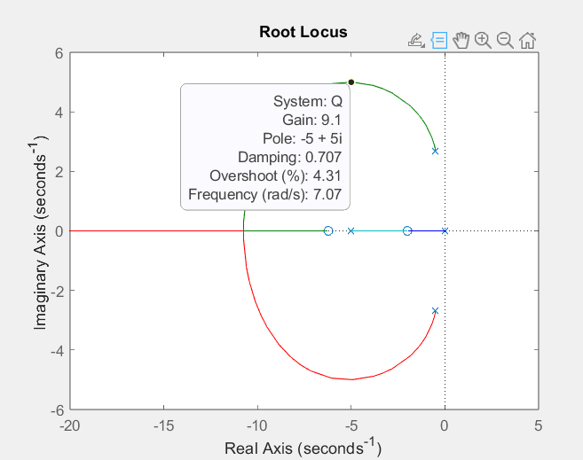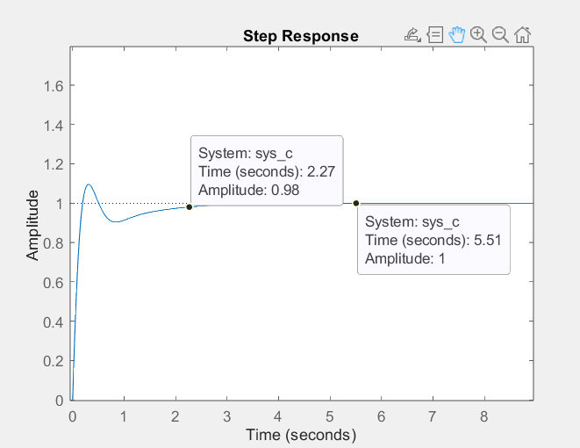

**Task4 4.1): To compare the effects of PD controller and PID controller, we use their root locus and step response. As we can see, the poles on the PD controller are closer to the imaginary axis than PID. Depending on the rules of the second-order system:**

**Ts = 4 / ζ * Wn**

**The PD controller has lower Ts which means this system is more stable than PID controller. Besides, The PID have a new pole s=0 and a new zero s=-2. Both of them are close to the imaginary axis and will have the effect to root locus which is nonnegligible. So that’s the reason that PD controller is more stable than the PID.**

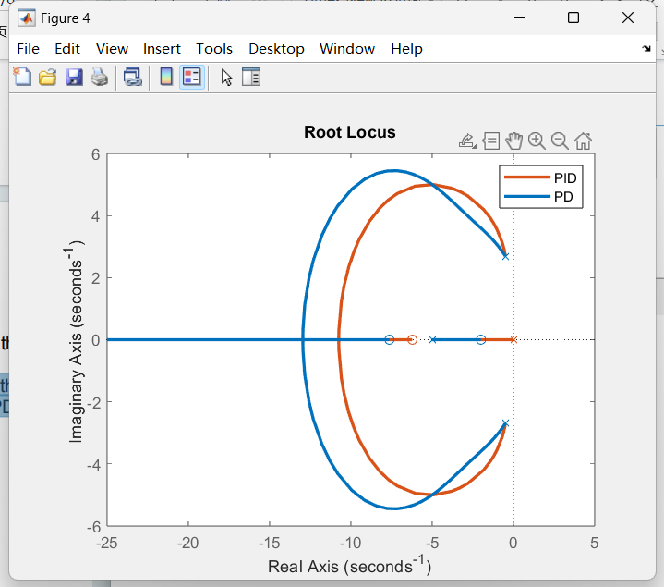

**According the image of step response, we can find that the PID has a longer settling time (Ts = 2.26s) than PD (Ts = 0.976s). On the other hand, the PD has a higher percentage overshoot which is (0.974-0.751)/0.751 = 29.69% than the PID controller which is (1.1-1)/1 = 10%. Finally, the PID have a higher final value than PD which means PID has the less steady state error.**

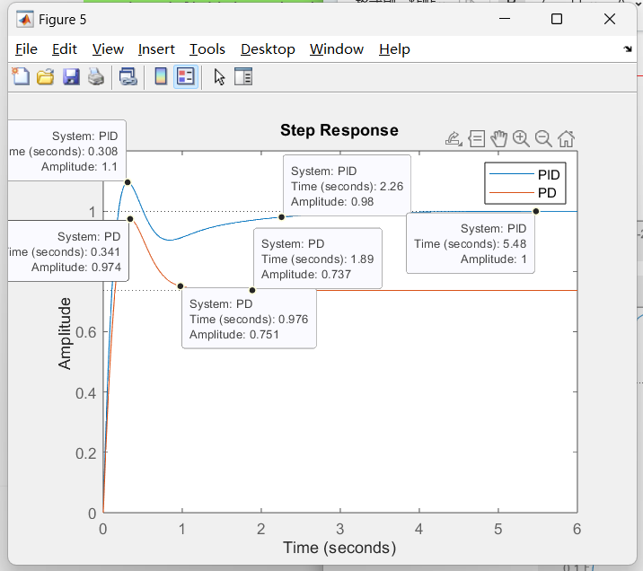

**Task4 4.2): At first we adjust the K value of G(s) as 9.96 to get the new step response of controller (because the gain is not scalar now)**

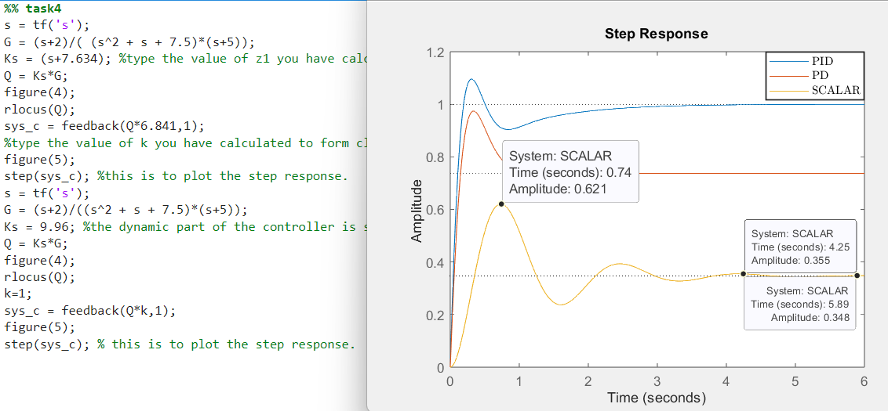

**Then, we will change the Ks of PID and PD controller to get a new step response for scalar controller. So we choose the gain of their collision points, I choose the k value as 20 for both of them.**

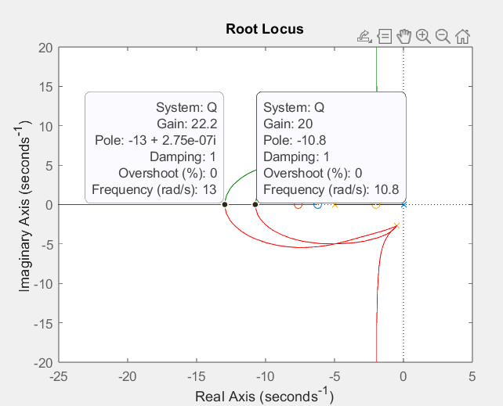

**Then we can find a new image of two step responses. Both of them have a lower Ts than before( PID Ts = 1.45, PD Ts = 0.83). They also have lower percentage overshoot tahn before ( PID is 8.32%, PD is 15.47%). The PD has less steady state but PID increases a little.**

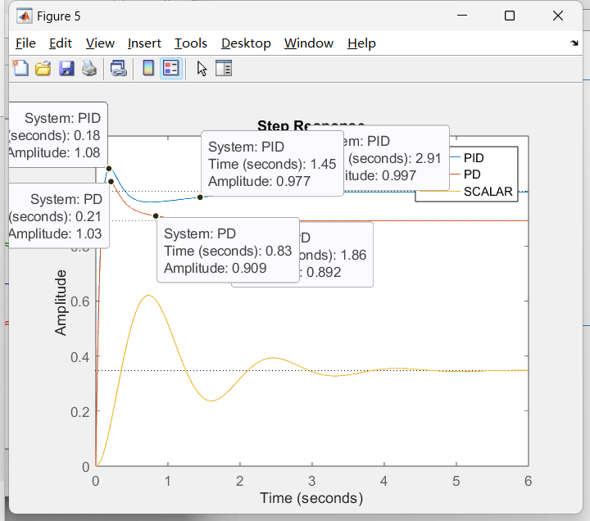

**Part B: Frequency Response**

**Now we will use a lead/lag compensator to design a close-loop transfer function.** 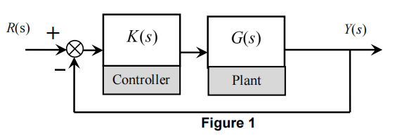

**G(s) = 4/(0.9s^2 + s + 1)**

**Task5 5.1): Type the code and we can obtain the bode diagrams. The crossover frequency ω0 equals the frequency at 0 dB, so the ω0 equals 2.2 rad/s**

**Then, we can obtain the phase margin at ω0 whcih is 33 degree.**

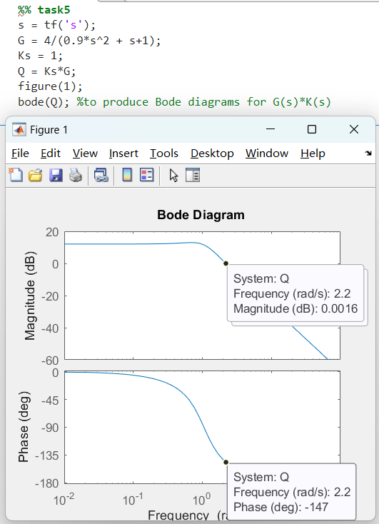

**Task5 5.2): This is a second-order system close-loop transfer function.**

**We can make k as 4/5, so that the Wn^2 in numerator will equal to Wn^2 in denominator. Wn=2.36, ζ=0.236**

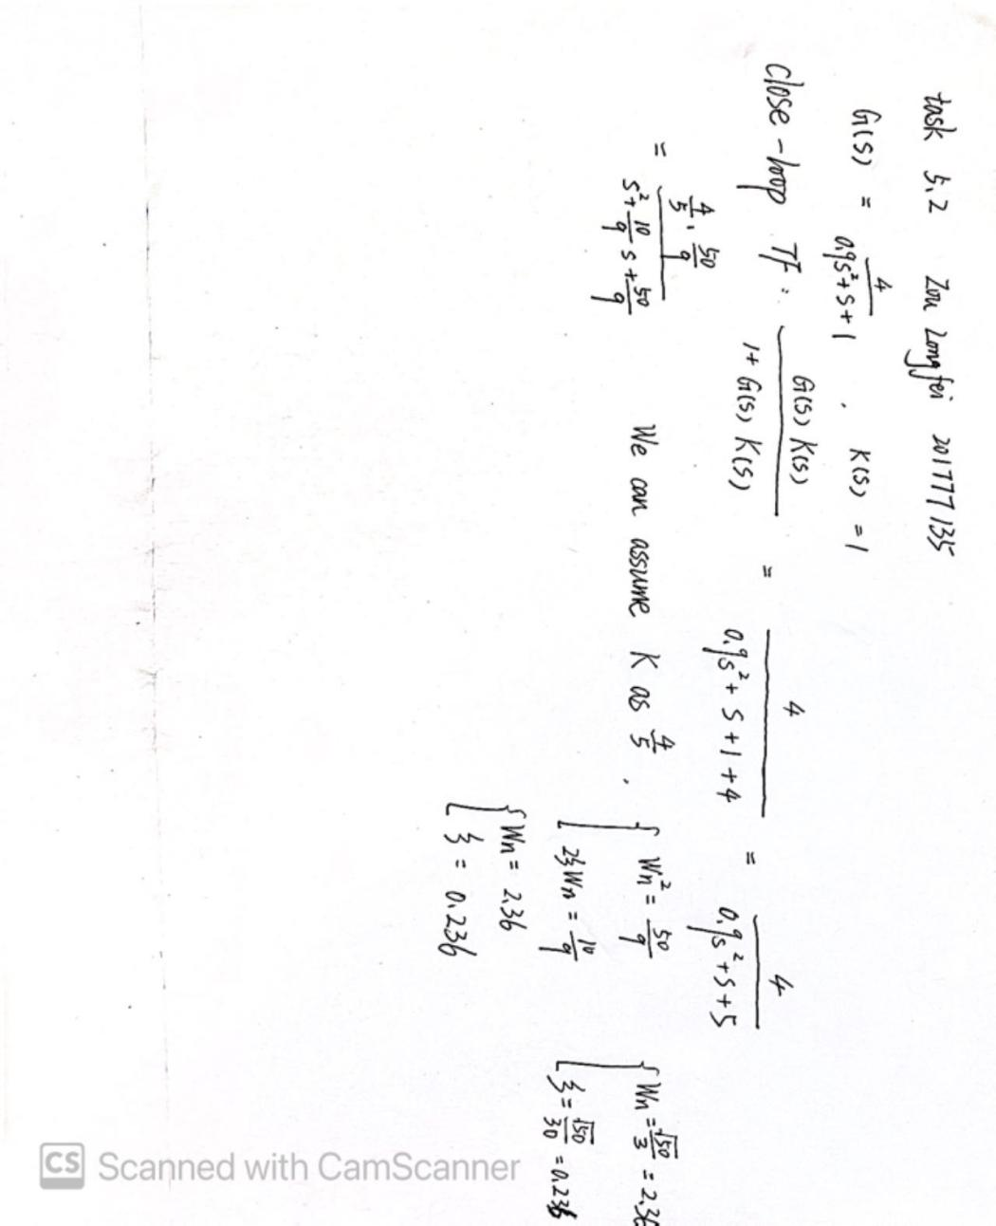

**Task5 5.3): If the closed-loop bandwidth is approximately equal to ω0 where the PM is 33 degree, the damping ratio is 100*ζ which is 23.6 degree. There are some difference between PM and 100*ζ, the error is 33 - 23.6 = 9.4 degree.**

**Task6 6.2): the crossover frequency is 6.13 rad/s. So at this point, the gain needs 18.4 dB and PM is 180 - 169 = 11 degree.**

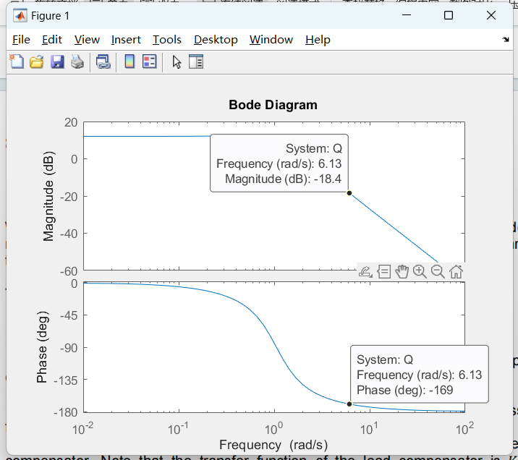

**Task6 6.3):**

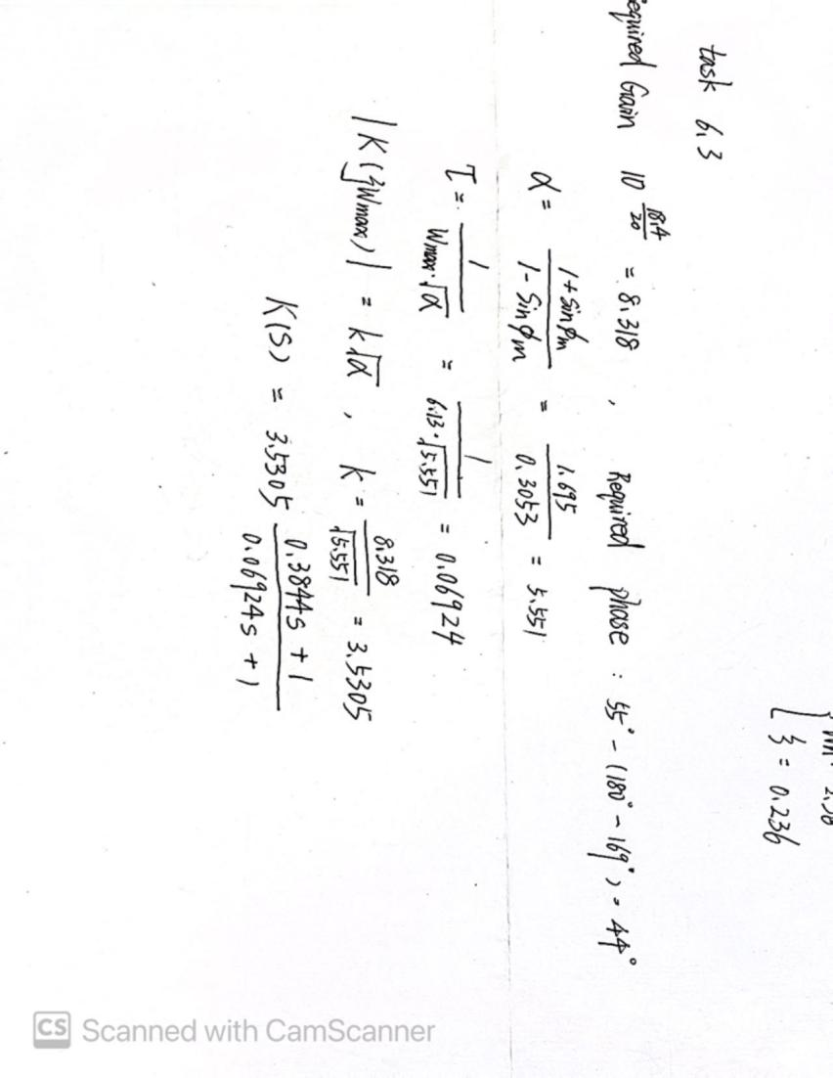

**Task6 6.4):**

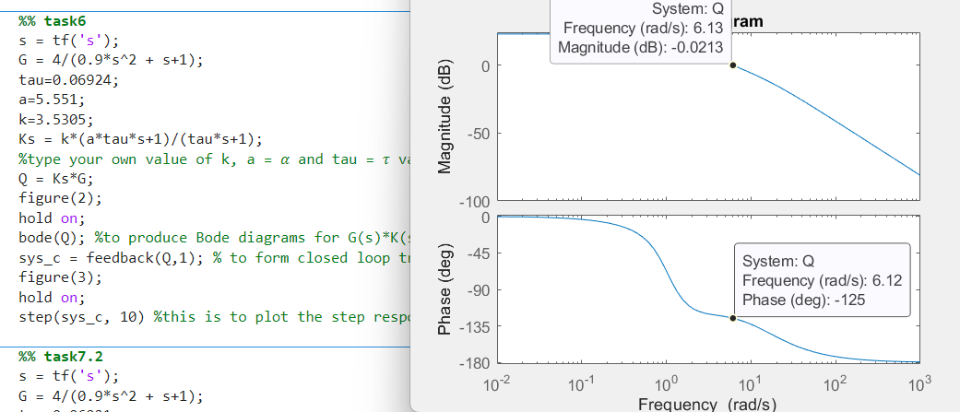

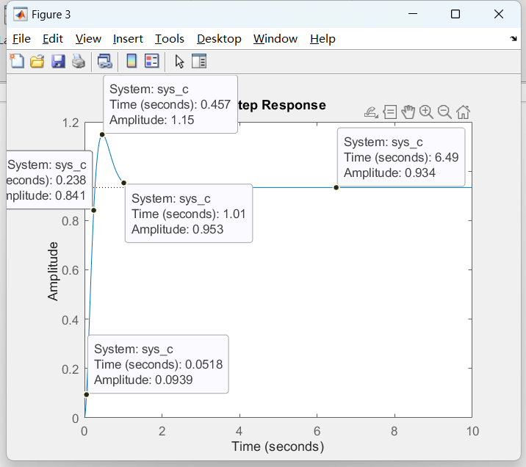

**The settling time Ts is amplitude equal 1.02*0.934 = 0.9527, so Ts is around 1.01s. The rising time is the amplitude from 10% to 90% so that we can use the time at 90% amplitude to reduce the time at 10% amplitude, Tr = 0.238 - 0.0518 = 0.1862s. The value of overshoot is (1.15-0.934)/0.934 = 0.2313 = 23.13%**

**Task7 7.1): We know that R(s) = 1/s , E(s) = R(s)/(1+G(s)*K(s)) , K(s)=Klag(s)*Klead(s) and the final value theorem. We can obtain Klag(s) = (7.0103*(0.6159s+1)) / (4.319s+1).**

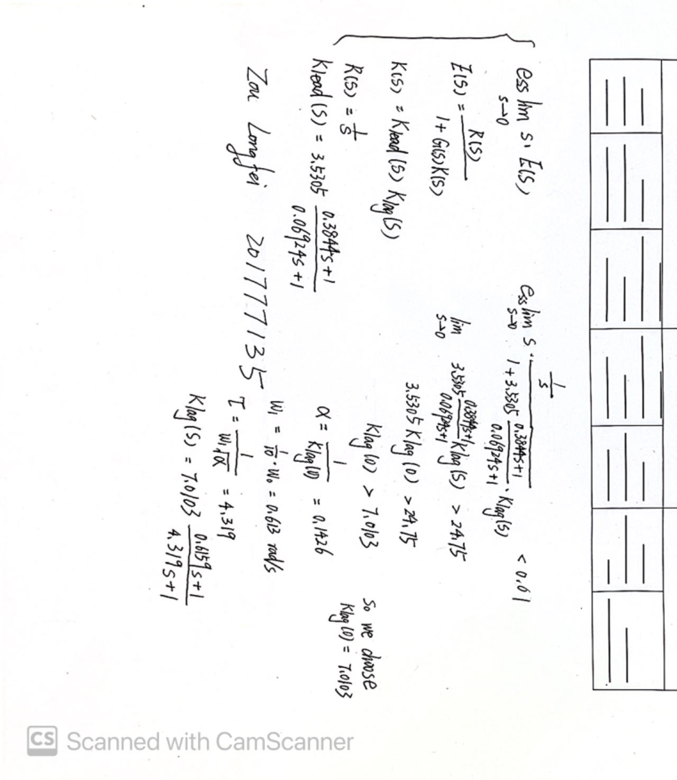

**·Task7 7.2): First let’s compare the Bode plots of phase lead and lead-lag compensators.**

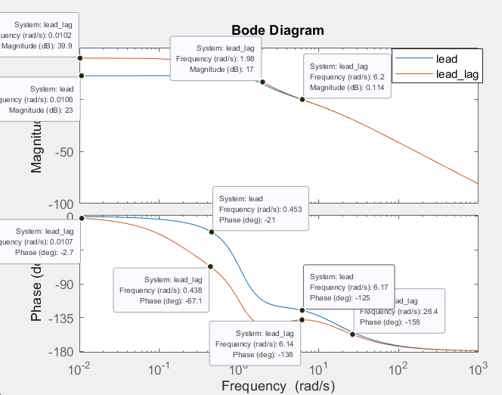

**We can see the lead-lag compensator has a higher magnitude at the low frequency than the lead compensator. For example, the magnitude of lead compensator at ω = 0 is23 dB but the lead-lag compensator is 39.9dB. When the frequency higher than 2 rad/s, their magnitude are almost same.**

**As for the phase, we can see that the phase of lead compensator is always higher than lead-lag compensator. Both of them are zero when the frequency is zero. But the phase of lead-lag compensator decreases faster than the lead compensator. They have the biggest difference which is ( -67 - (-21) )when the frequency is 0.45 rad/s. With frequency becomes higher, their difference are less. They are almost same when frequency higher than 26.4 rad/s.**

**So we have the conclusion that the lead compensator has higher phase in the low and medium frequency but less magnitude in the low frequency than the lead-lag compensator.**

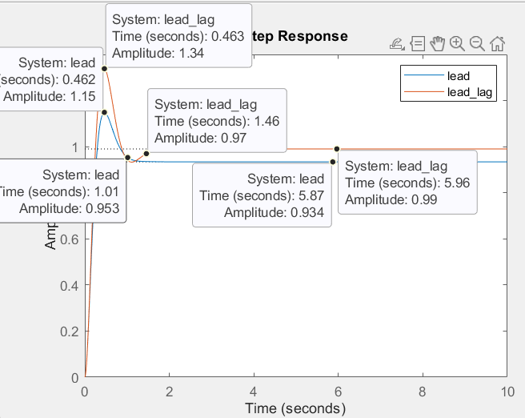

**Now let’s have a look about the step response. They have the same peaking time (Tp = 0.462s).However, the lead compensator has a lower settling time (Ts = 1.01) , lower overshoot (23.13%), and higher steady state error( 1 - 0.934 = 0.066 ).The lead-lag compensator has a bigger settling time (Ts = 1.46) , higher overshoot (35.35%) and less steady state error ( 1-0.99=0.01 )**

**Task7 7.3): Let’s change different k value as 0.5,3 and 10. Then check their step response and find the difference.**

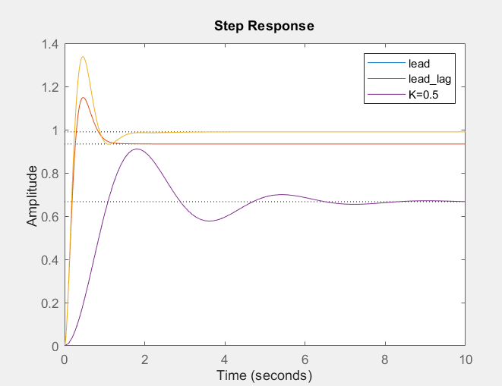

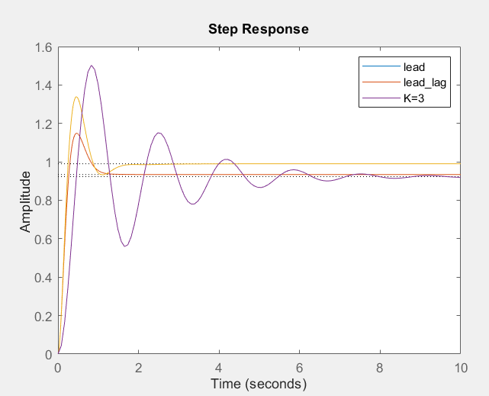

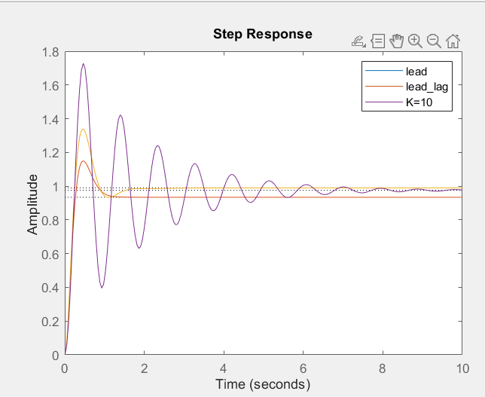

**As we can see, with the K value increasing from 0.5 to 3 until 10, the steady state are less and the overshoot are larger. We also can find that the faster oscillation of step response and less peaking time (Tp) when we increase the K value.**